**Tutorial – 6**

**1.** Design an application like follow. Depends on user selection it will display the message as shown. (If gender is Male then Mr. or Female then Miss)

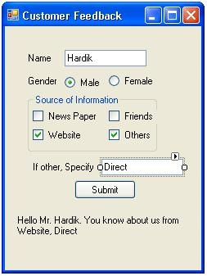

**Code:**

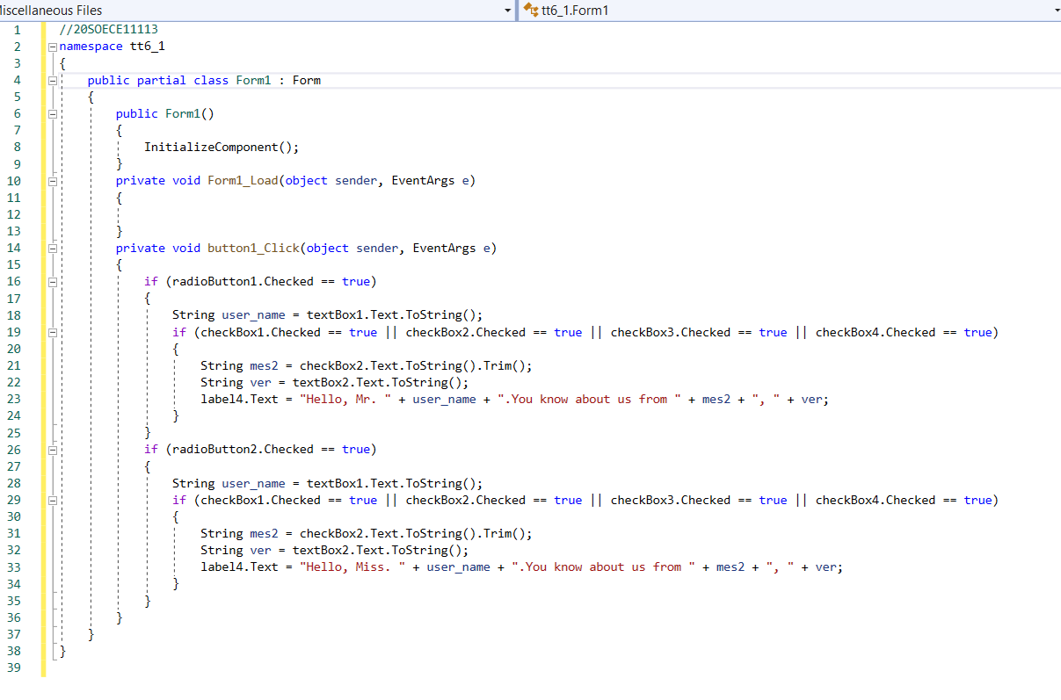

**Output:**

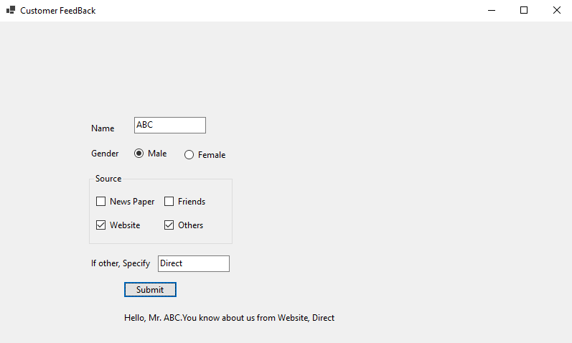

**2.Design a form like below. Implement Following functionality to the application.**

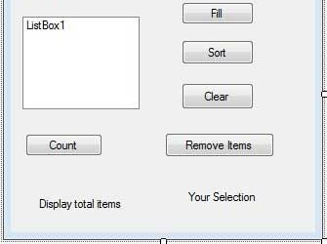

**Code:**

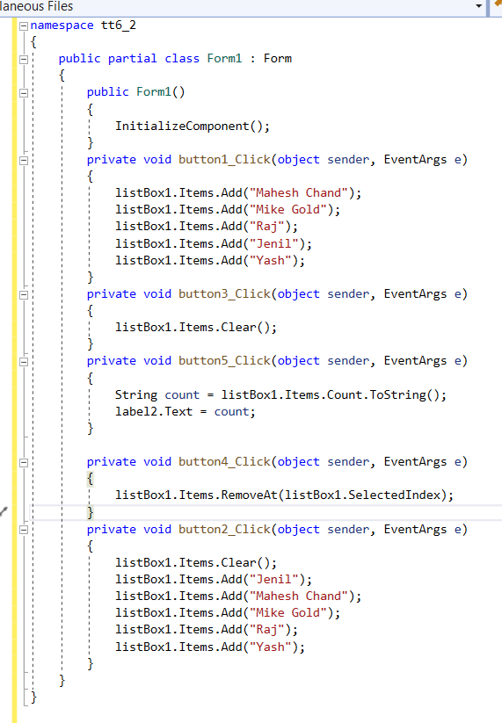

**Output:**

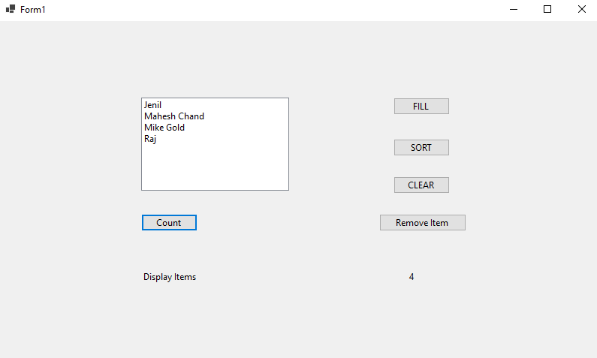

**3.Design an application which has three textboxes. Implement restricted policy for each textbox to enter data only in numeric form, uppercase, characters.**

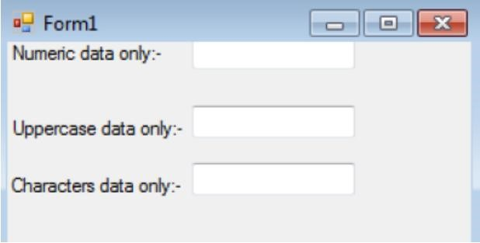

**Code:**

namespace tt6_3

{

public partial class Form1 : Form

{

public Form1()

{

InitializeComponent();

}

private void button1_Click(object sender, EventArgs e)

{

}

private void textBox1_KeyPress(object sender, KeyPressEventArgs e)

{

if (!char.IsControl(e.KeyChar) && !char.IsDigit(e.KeyChar))

{

e.Handled = true;

MessageBox.Show("Numeric Text");

}

}

private void textBox2_KeyPress(object sender, KeyPressEventArgs e)

{

if (!char.IsControl(e.KeyChar) && !char.IsUpper(e.KeyChar))

{

e.Handled = true;

MessageBox.Show("Upper Text");

}

}

/*private void textBox3_TextChanged(object sender, EventArgs e)

{

}*/

private void textBox3_KeyPress(object sender, KeyPressEventArgs e)

{

if (!char.IsControl(e.KeyChar) && !char.IsLower(e.KeyChar))

{

e.Handled = true;

MessageBox.Show("Lower Text");

}

}

}

}

**Output:**

